1
Customer Guide to MetroAccess

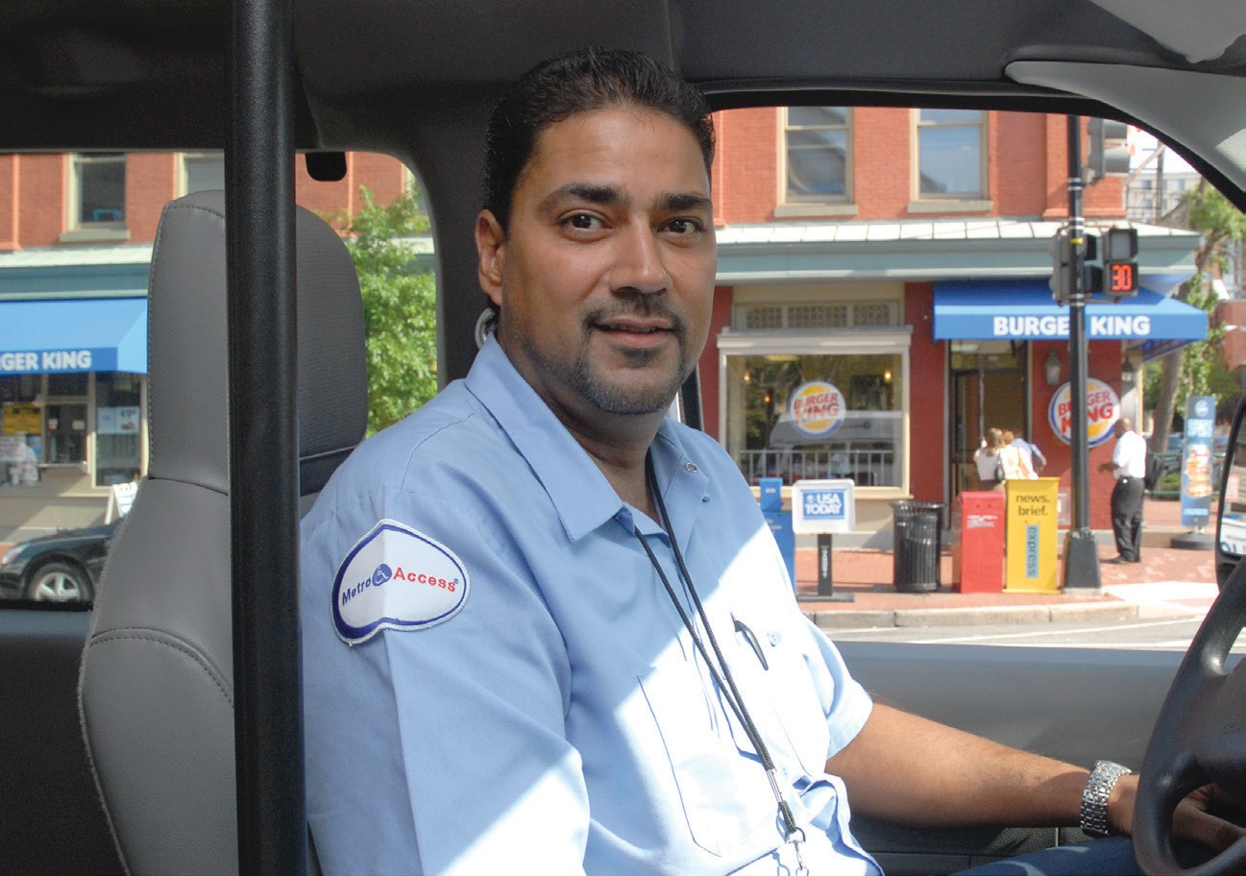
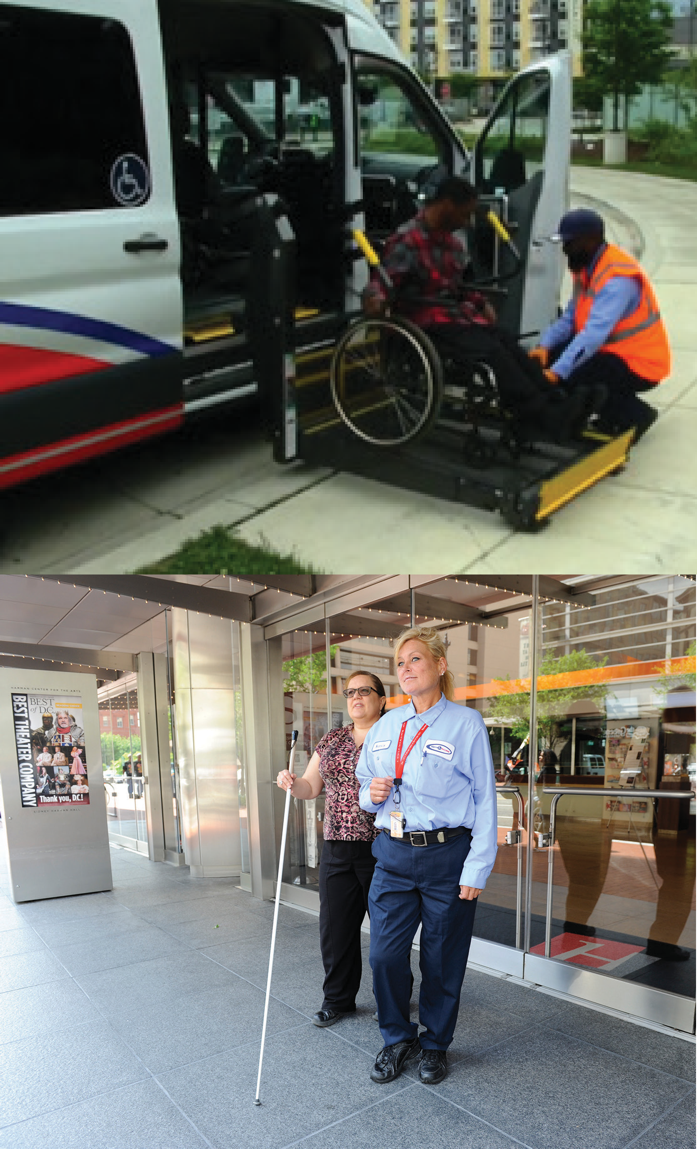
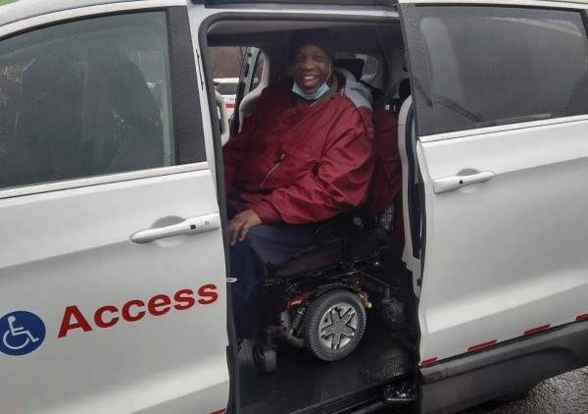
See the Q&A about changes to MetroAccess


Effective July 2024

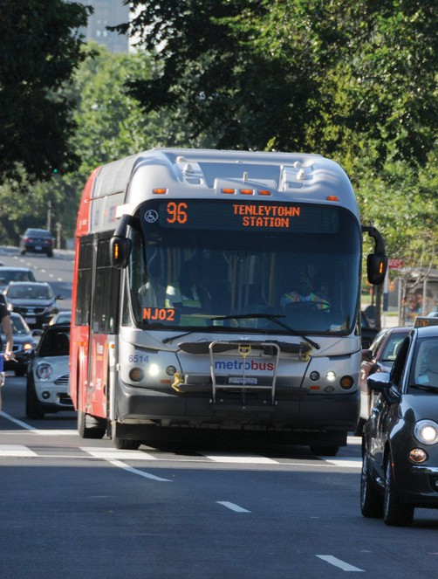
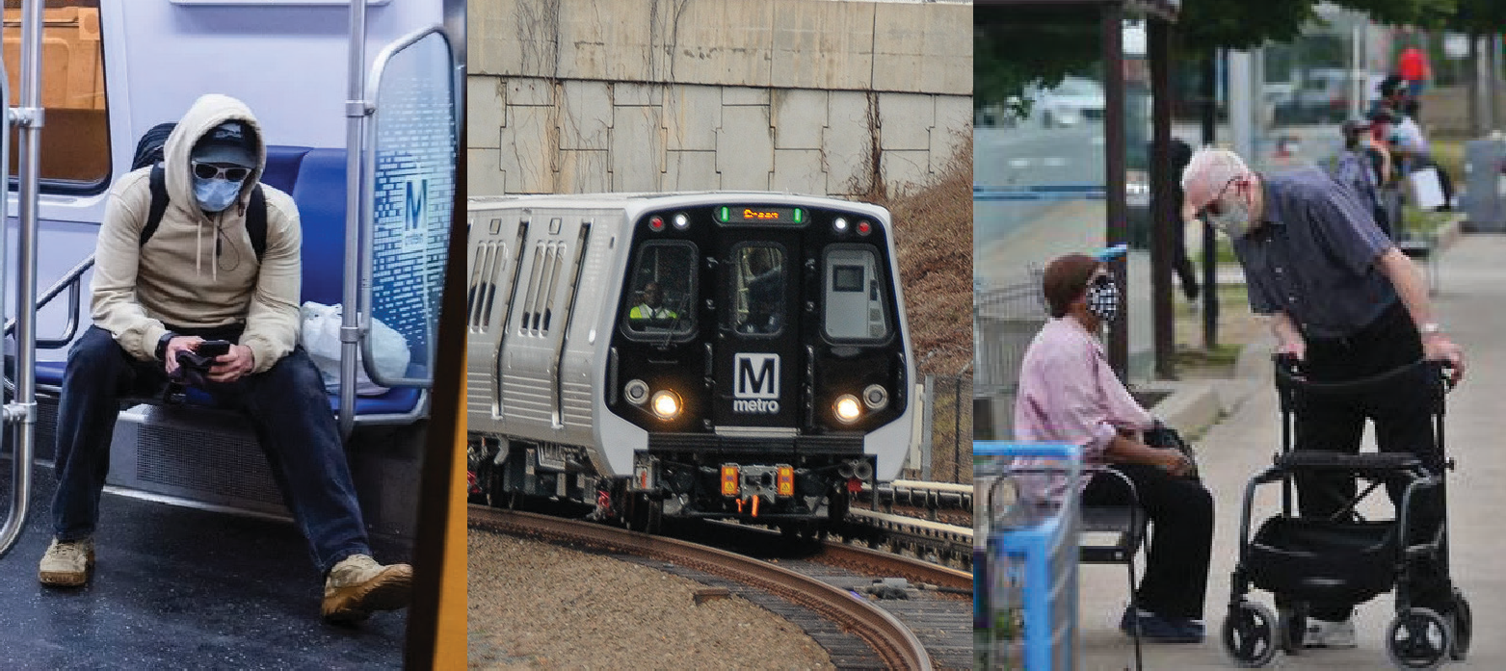
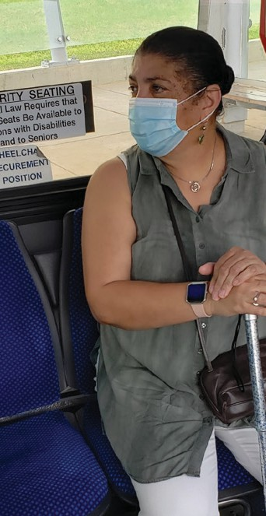

Get more out of Metro with Travel Training.

At Metro, we’re dedicated to helping customers get where they’re going and to showing them all other available options.

We offer free travel training for individuals and groups. Our sessions are customized to meet specific needs and our professional staff will train onsite at designated customer locations. We cover basic riding skills like navigating rail stations, trip planning, finding bus stops and paying fare.

Free rides on Metrorail and Metrobus for MetroAccess customers

Some MetroAccess customers are entitled to free rides on Metrorail and Metrobus. It’s a great way to save money!

For more information about Metro’s free travel training, call 202-962-2780.
2

Contents

What Is MetroAccess? 4
Customer Bill of Rights 4
Customer Responsibilities 4
Customer Safety Responsibilities 5
MetroAccess Fares 5
MetroAccess Service Area 5
Fare Payment Policy 5
Service Hours 6
Contacting Us 6
How and When to Schedule a Trip 6
Online Reservations 7
Scheduling Tips 7
EZ-Pay is a Better Way to Pay 7
EZ-Pay Works with SmartBenefits® 8
Managing the EZ-Pay Account 8
Access EZ-Pay by Phone 8
Access EZ-Pay by Internet 9
Access EZ-Pay In-Person 9
Subscription Service 10
Door-to-Door Service Requirements 11
Scheduling Windows 12
Pick-up Windows 12
Late Trip Credit 12
Customer No-Show and Late Cancellation Policy 12
Fixed-Route Equivalent, Shared Ride Service, & Expected Ride Time 14
MetroAccess “No Strand” Policy 14
Seatbelt Securement Policy 15
Driver Assistance for Customers 15
If You Need Additional Assistance 16
What You May Bring with You 17
MetroAccess Vehicles 18
Direct Threat and Abusive Behavior 18
Severe Weather or Hazardous Conditions 18
Commendations, Suggestions, and Complaints 19
Lost and Found 19
Travel Training 19
MetroAccess Eligibility 19
MetroAccess ID Cards 20
MetroAccess SmarTrip® ID Cards for Customers with Conditional Eligibility 20
Abilities-Ride Program 23
Frequently Asked Questions about MetroAccess - Paratransit Service 24
Frequently Asked Questions about MetroAccess - Eligibility 25
Frequently Asked Questions about MetroAccess - MetroAccess Service 27
Frequently Asked Questions about MetroAccess - Alternatives to MetroAccess 31
MetroAccess Pick-up/Drop-off Locations at Metrorail stations 33
Event Calendar 34
Useful Numbers 34

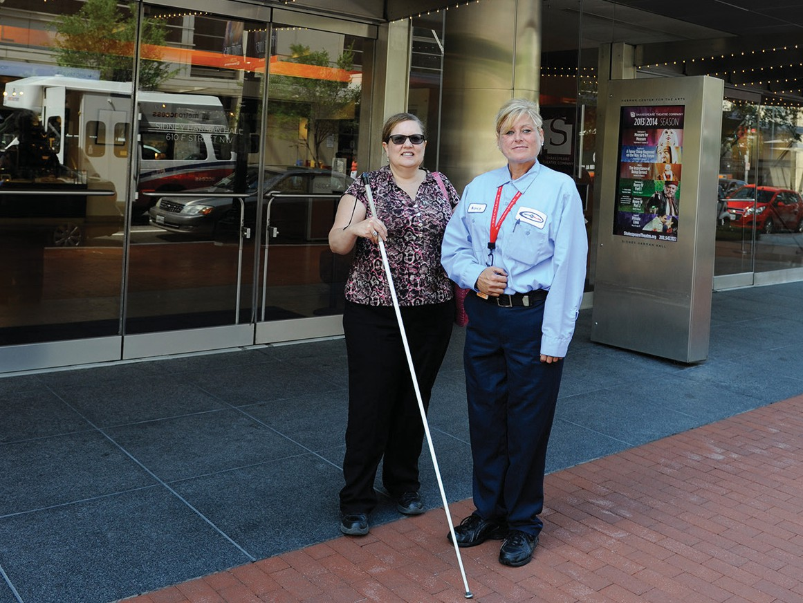
What Is MetroAccess?
In accordance with the Americans with Disabilities Act (ADA), MetroAccess is the region’s complementary paratransit service offered by the Washington Metropolitan Area Transit Authority (WMATA, commonly known as Metro).
A shared ride, fixed-route equivalent public transportation service, MetroAccess provides scheduled trips for people who are unable to use fixed-route public transit due to disability.
MetroAccess provides trips within the metropolitan Transit Zone that includes the District of Columbia, Montgomery and Prince George’s Counties in Maryland, Arlington, Fairfax and Loudoun Counties, and the cities of Alexandria, Fairfax and Falls Church in Virginia. Services are offered during the same service areas and hours of operation as Metrobus, Metrorail, and locally operated transit service.

To learn more about the ADA, visit ada.gov.

Customer Bill of Rights
MetroAccess customers have a right to:
- Timely pick-up within a 30-minute pick-up window
- Safe transportation
- Courtesy and respect
- A clean, well-maintained vehicle
- Prompt attention to concerns that are investigated, addressed, and resolved in a timely manner
- Professional, prompt and courteously answered calls
- Quality transportation services equivalent to those offered on Metrobus and Metrorail

Customer Responsibilities:
MetroAccess customers should expect to:
- Be ready for pick-up throughout the entire 30-minute pick-up window
- Display a valid MetroAccess ID Card to the driver before boarding
- Pay exact fare before boarding
- Utilize required vehicle restraints during transport
- Keep service animals under control
- Avoid eating, drinking, or smoking in MetroAccess vehicles
- Treat drivers, other riders, and
- MetroAccess staff with respect
- Avoid disruptive or abusive behavior
- Maintain good personal hygiene
- Cancel reservations two or more hours before the scheduled pick-up
- Provide up-to-date information to the Transit Accessibility Center, including home address, phone number, types of mobility aids you use, and accessible format needs

Customer Safety Responsibilities:
Customer safety is our top priority! Help us keep MetroAccess safe by following these safety tips:
  - Partner with the MetroAccess driver – follow their safety instructions.
  - Accept driver escort offers (take the driver’s arm for balance) or prepare to walk near the driver, so that he/she can provide alerts to hazards along the path of travel.
  - Know your limits - bring a Personal Care Attendant (PCA) along if:
    - You need support when walking to/ from the vehicle (or bring a mobility aid).
    - You cannot be left alone at the drop-
off location.
  - Ensure that personal assistance/ mechanical devices (ex. wheelchair, scooter, oxygen device) operate without driver intervention.
  - Keep mobility aids in good working order.
  - Be able to operate power chairs safely.
  - Ensure that brakes operate as designed.
  - Make sure privately-owned ramps, sidewalks, and walkways are maintained and are clear of obstructions, snow, and ice.
  - Ambulatory customers utilizing the vehicle lift should use handrails for safe boarding.

MetroAccess Fares
Your MetroAccess fare is calculated at twice the fastest fixed route equivalent fare, with a maximum fare of $4.50. Your total fare is communicated at the time of trip booking.
MetroAccess Drivers will ask cash paying customers to pay at the door, upon first contact. Should a customer prefer to
pay at the vehicle, they can. Payment, however, must be rendered before boarding the vehicle. Drivers do not carry or make change.
Whenever possible, customers should use MetroAccess EZ-Pay system to pay for MetroAccess trips.
For more information, see page 9.

MetroAccess Service Area
Customer trips begin and end within three-quarters of a mile, or less, from the nearest fixed-route bus stop or Metrorail station in the Transit Zone (see ‘What is MetroAccess?’ on page 4).

Fare Payment Policy
Full and exact payment of MetroAccess fare is required for all trips. Whenever possible, payment should be pre-paid through EZ-Pay or presented in exact change, to MetroAccess drivers before customer, personal care attendant (PCA), and/or companion boards.

Customers have the right to travel with one PCA and should indicate their intent to do so when making a reservation. One PCA is eligible to ride for free per customer trip.
Any additional rider accompanying the MetroAccess customer is considered a companion and must pay full fare for each ride, unless the companion is a child under five years old.

Service Hours
MetroAccess typically operates 7 days a week, 365 days a year, providing service within three-quarters of a mile of existing fixed-route services like
Metrobus, Metrorail, and jurisdictional bus services. MetroAccess does not operate when Metrobus and/or Metrorail are not operating.
Please check with MetroAccess at 301- 562-5360 to verify service availability in your area.

Contacting Us
Customers may contact MetroAccess via phone and can either use the automated response system or speak to
a representative. Customers may use the automated telephone service to confirm a trip, cancel a trip, and obtain customer account information.
This system is available 24-hours a day.
Main Phone Number: 301-562-5360 TTY: 301-588-7535

How and When to Schedule a Trip
To schedule a trip, call MetroAccess at 301-562-5360 and press the option for Reservations or TTY 301-588-7535. If you are out of the service area, call 1-800- 523- 7009.
Reservation agents are available seven days a week, 8 a.m. to 4:30 p.m. For fastest answer times, please call between 11 a.m. and 2 p.m.
Customers may schedule trips up to seven days in advance. MetroAccess does not provide same-day trip service.
Please be prepared to provide the exact address of your pick-up and drop-off locations. If your pick-up location is at a building with more than one entrance, please indicate the specific pick-up entrance (e.g., front red door). If the building has a name, please provide the name of the building when booking trips. Be sure to tell the reservation agent if a mobility aid, companion or personal care attendant (PCA) will be in use during travel. If travelling with a PCA/companion, please also notify the reservation agent if the PCA/companion plans to travel with a mobility aid.
Please be prepared to provide a best contact phone number in cases of a service delay.

Online Reservations
Customers may book or cancel trips on the Metro website. To book MetroAccess trips:
- Go to wmata.com. Once on the home page, place the mouse over
“Service” on the top menu bar and click “MetroAccess.”
- Once on the Accessibility page, click on “Web Booking” in the left menu.
- Scroll down the page to the “Trip Planning” section, and under “Web Booking” click the link “Web booking site.”
- Log in using the assigned MetroAccess Customer ID and password.
To change the MetroAccess password, please contact Metro’s Office of Eligibility Certification at (202-962-2700).

Scheduling Tips
  - Be sure to schedule return and pick-up trips at the same time. MetroAccess does not offer same day service. When planning a return trip, allow at least one hour from the drop-off time, doing so ensures a return trip pick-up window that can be accommodated.
  - Customers that must arrive at destinations by a specific time, should inform Reservations Agents to book such trips by appointment time.
  - Be sure to consider traffic, shared rides with other customers, and other possible delays when booking by appointment time.
- When MetroAccess is unable to provide a trip at the specific time requested, the agent will help select another time within a scheduling window of 45 minutes before and 45 minutes after the originally requested time. MetroAccess will make every attempt to ensure a timely arrival.
- Be certain to provide as much information as possible that may assist the driver in locating exact pick- up
or drop-off locations. For example, providing details like color or type of building, and store or business name can significantly improve the pick-up experience.
- Please provide a telephone number to be used for contact at the time of pick-up; your home phone number will
not help with a pick-up away from your home. (Please remember to verify or update contact information with the Office of Eligibility Certification and Outreach.)
- MetroAccess does not prioritize trips by type or purpose. All trips are treated with equal priority.
EZ-Pay is a Better
Way to Pay
With EZ-Pay, customers can prepay MetroAccess fare by phone and internet with a credit or debit card. Customers can also pay in-person with cash or card at the Transit Accessibility Center (TAC) Office.
EZ-Pay allows customers to view trip history and monitor trip credits. The service is secure and convenient, and eliminates the need to pay with cash when using MetroAccess.

EZ-Pay works with SmartBenefits®
Customers that receive transit
benefits through employer-sponsored SmartBenefits® programs can direct these benefits to MetroAccess.
To direct SmartBenefits® to the MetroAccess EZ-Pay account:
- Log in to SmarTrip® account online.
- Click on the card used for
SmartBenefits.
- Click “Manage SmartBenefits.”
- Go to the “Transit Allocation” section, click “Add Transit Provider” and select “MetroAccess.”
- Follow the prompts to complete the allocation and establish ongoing monthly deposits.
- Complete any account modifications by 11:59 p.m. ET on the 21st of each month for the upcoming month’s benefits.
For more information on SmartBenefits®, customers should contact their employer or transit benefit provider.
Managing the
EZ-Pay Account
With EZ-Pay, customers can easily add money and track account balances.
Customers can add value to the EZ-Pay account using their Visa, MasterCard, American Express or Discover card.
MetroAccess reservation agents can also provide account information during the reservation process.
The EZ-Pay account must have funds available prior to making a reservation. Funds are deducted from the EZ-Pay account at the time of trip booking, not when the trip occurs. Subscription trips require funds availability eight days before the first subscription trip(s) occur(s).
Subscription trips are automatically cancelled for all federal holidays. If customers choose to re-book trip(s) as a non- subscription trip on a federal holiday, funds should be available prior to booking, otherwise customers should be prepared to pay with cash on the day of travel.

Access EZ-Pay by Phone:
- Call MetroAccess at 301-562-5360 and select the EZ-Pay account option. When out of the service area, call
1-800-523-7009.
  - To log in, enter the MetroAccess customer ID, followed by the # key.
  - Enter the MetroAccess password followed by the # key.
- Select option to add value to the EZ-Pay account.
- Select option to hear the EZ-Pay account balance.
- Select option to speak to a representative, when needed.
Account balances reflect trips booked, but not yet taken. Upon booking, trip fare is deducted from current account balance.
If a scheduled trip is cancelled, fare is automatically refunded to the account.

Access EZ-Pay by Internet:
- Visit wmata.com. Once on the home page, place the mouse over “Service” on the top menu bar and click “Accessibility.”
- Once on the Accessibility page, click on “MetroAccess” in the left menu.
- Scroll down the page to the “Pre-Pay Fares with MetroAccess EZ-Pay” section, and select “MetroAccess
EZ-Pay”.
- Scroll down the page to the “By Internet” section, and select “MetroAccess EZ-Pay.” Or type this URL into the web browser: eztransport.com/WMATA/ MembersPortal/default.asp.
- Log in to the MetroAccess EZ- Pay Account with Username (MetroAccess customer ID number) and password.
- Select from the following options: “View Balance,” “View Transactions,” “Add Value,” or “Log Out”.
  - The “View Balance” option displays the current account balance. Please note that account balances reflect trips booked, but not yet taken. Upon booking, trip fare will be deducted from the current account balance. If a scheduled trip is cancelled, fare will be automatically refunded to the account.
  - The “View Transactions” option allows customers to enter a date range to display a descriptive list of account transactions. Keep in mind that transaction dates reflect the date that a trip is booked, not taken. To view cancelled trips, select the “Display all transactions” checkbox.
- The “Add Value” option allows customers to add funds to EZ-Pay accounts. Once submitted, the value will immediately appear in the transactions list.
- Click “Log Out” to complete adding funds to the EZ-Pay account, or to complete a review of account balances and transactions.

Access EZ-Pay In-Person:
- Go to The Transit Accessibility Center (TAC) located at Metro headquarters, 655 Virginia Ave SW, Washington, DC 20024. The TAC office is open 8 a.m. to 4 p.m., Monday through Friday.
- Inform the sales agent of the need to add money to the MetroAccess EZ-Pay account. Please note that the balance provided by the agent reflects trips that have been booked, but not yet taken.
- Be prepared to show the MetroAccess photo ID to the sales agent.
- Use cash, Visa, MasterCard, American Express, or Discover card for payment. An email address is required when paying by credit card.

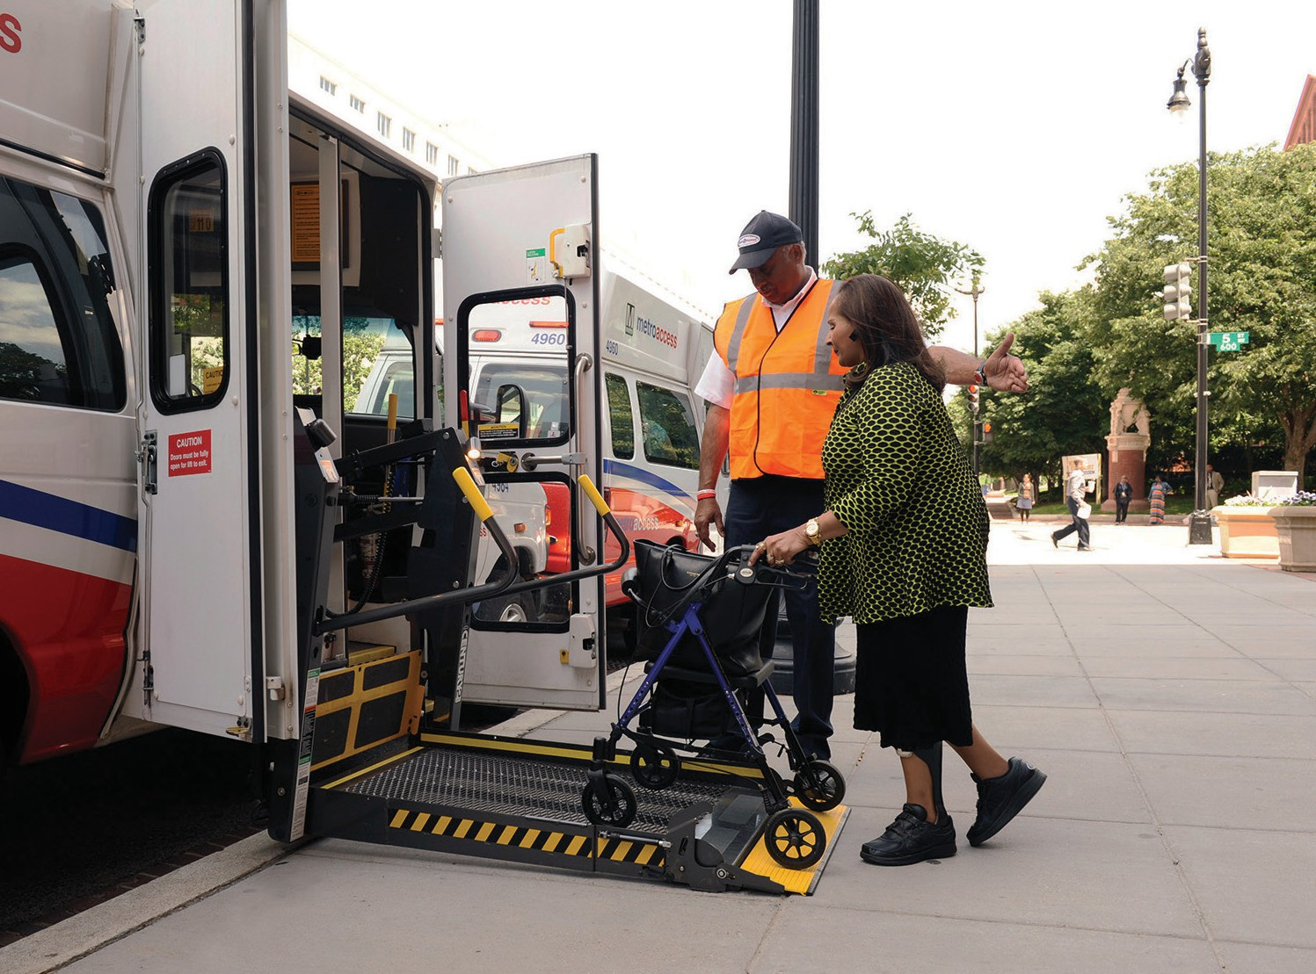

Subscription Service
Customers that take the same trip, at the same time, on the same day of the week, between the same addresses may qualify for MetroAccess subscription service.
Trips like regular doctor appointments or daily work travel are perfect for
MetroAccess subscription service. Once customers establish subscription service, there is no need to call and schedule these pre-arranged trips. To qualify for subscription service, customers must demonstrate regular travel patterns. Unlike non-subscription trips, subscription trip fare is deducted seven days in advance.
Accordingly, customers must ensure there are sufficient funds in their EZ-Pay accounts eight days in advance of their trip. MetroAccess subscription trip terms and conditions are listed below:
  - Customers must demonstrate regular travel to the destination over a 30-day period before submitting a subscription service request. That is, customers should have demonstrated travel to the same destination, with similar pick- up and drop-off times, at least once a week, for a 30-day period.
  - Subscription service requests may take up to seven business days before implementation. Until subscription service begins, customers should continue to book trips individually.
  - Customers can modify details of their subscription trips once every 30 days.
Changes may include appointment time, customer contact number, and special
instructions. Modifications to pick-up time will be negotiated per the regular MetroAccess reservation process.
  - If the destination and/or origin address changes, the customers should cancel current subscriptions and submit a new subscription trip request. As with the initial subscription, the customer must demonstrate a regular trip pattern for subscription trip consideration.
  - Subscription service is suspended on all federal holidays.
  - Customers may request a temporary suspension of subscription service for a maximum of 30 days within a rolling 90-day period.
  - If 25% or more of subscription trips are cancelled within a 30-day period, subscription service cancellation may occur.
  - Subscriptions that have been inactive for longer than 30 days are subject to cancellation. Customers are responsible for re-booking inactive subscription trips.
  - In cases where a previously existing subscription is re-instated after 30 days, the 30-day travel demonstration is not required.
To request a subscription, call MetroAccess at 301-562-5360 and press the option for Reservations. If you are out of the service area, call 1-800-523-7009. Tell the reservation agent that you would like to request subscription service.

Door-to-Door Service
Requirements
For the safety of our customers, MetroAccess provides door-to-door service. Door-to-door service means that MetroAccess drivers escort customers from the outermost exterior door of
the customer’s pick-up address onto the vehicle, and from the vehicle to the
outermost exterior door of the customer’s destination, whenever it is safe to do so. When drivers are unable to deliver door-
to-door service, customers will be asked to meet the vehicle at the curb. Curb-to-curb service is necessary when conditions like unsafe parking or construction interfere with access to the building entrance.
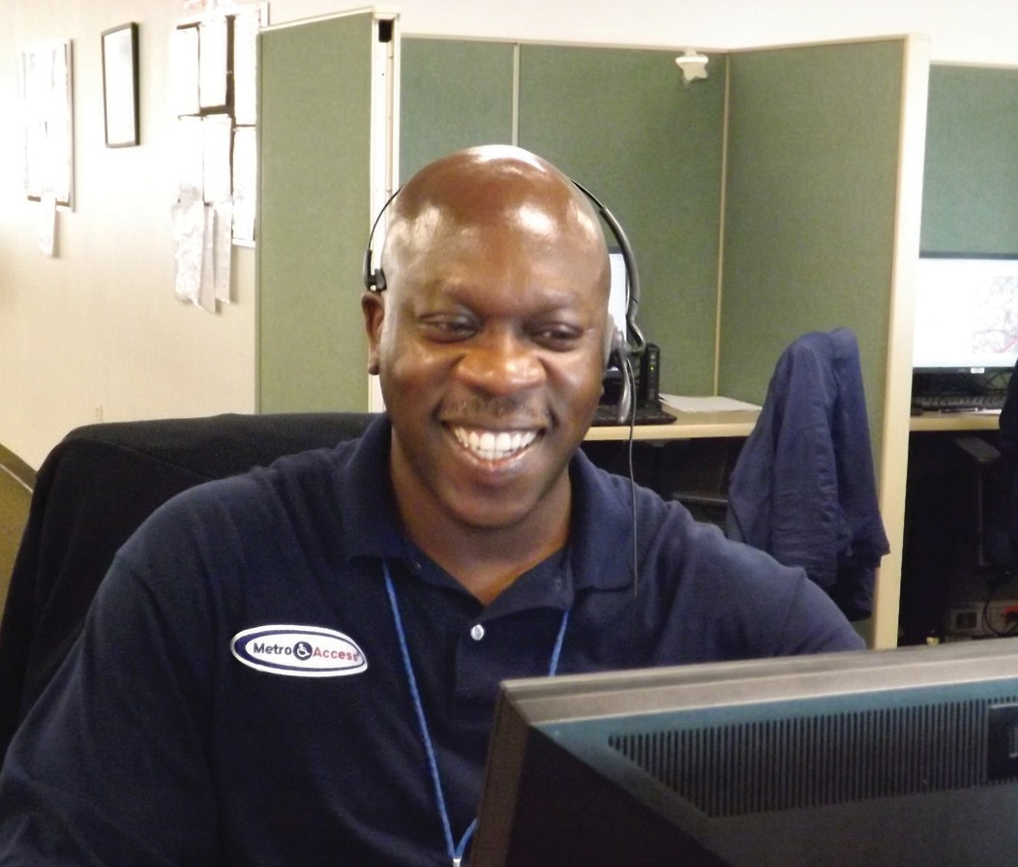
Customers should be prepared to board the vehicle at the beginning of the pick-up window. Customers can expect the driver to knock on the outermost exterior door for pick-up when the customer is not readily available upon arrival. At public entrances, drivers may open the first exterior door to announce their arrival; however, they are not permitted to enter the building. If the entrance has a second door leading to a
waiting area, drivers may open the second door and announce their arrival, but will not proceed into the waiting area. Drivers are not permitted to open doors at private locations or residences. Drivers will identify themselves as “MetroAccess.” Customers should display a valid MetroAccess ID card and be prepared to pay the exact fare before boarding the vehicle (if exact fare has not been paid already via EZ-Pay).
Drivers are strictly prohibited from waiting with customers at their destination.

Door-to-door service requires that:
  - The outermost exterior door is within 150 feet from the vehicle.
  - The driver maintains sight of the vehicle at all times.
  - There is a safe and accessible path from the vehicle to the door.
  - There is safe parking on a public roadway or public parking lot.
  - When parked, the MetroAccess vehicle
cannot block or impede traffic.
In cases where these conditions are unmet, curb-to-curb service will be offered. Customers should meet the driver at the curb for curb-to-curb service. Customers are responsible for getting to and from the curb by themselves.
When drivers arrive at locations that do not support door-to-door service, the driver will contact the Call Center to report that door- to-door service cannot be provided and request that the Call Center contact the customer. The customer will be apprised of the situation and advised to meet the vehicle at the curb.

Scheduling Windows
The trip scheduling process begins with a customer requesting a specific pick- up time. MetroAccess then attempts
to schedule the trip within a 90-minute window around the pick-up time; 45 minutes before through 45 minutes after the pick-up request time. This is known as the scheduling window. Once a pick-up time is agreed to, that establishes the pick- up window.

Pick-Up Windows
MetroAccess assigns a pick-up window during the trip booking process. The pick- up window provides a time period that the customer can expect to be picked up for their trip. These windows are 30-minutes long, and customers should be ready at the beginning of the pick-up window. For example, if a customer schedules a trip for 8:00 a.m., the pick-up window begins at the requested
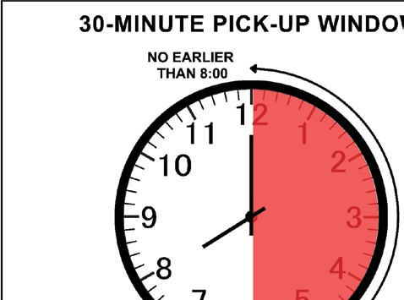
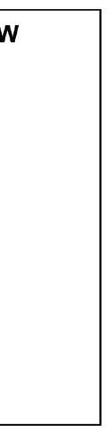

pick-up time and extends for 30 minutes. That is from 8:00 a.m.
to 8:30 a.m. The customer should be ready for pick-up at
8:00 a.m. Customers typically receive a courtesy phone call upon vehicle arrival and should be prepared to display a valid MetroAccess ID card and pay the exact fare before boarding the vehicle (if the fare has not been prepaid via EZ-Pay).
When on duty, MetroAccess drivers must wear visible ID badges at all times. If there are questions, customers can call MetroAccess at 301-562-5360 to confirm
driver identity.

Late Trip Credit
If the MetroAccess vehicle arrives after the end of the 30-minute pick-up window, MetroAccess will automatically apply a
$4.50 late trip credit to the customer’s EZ- Pay account. This credit is posted around seven business days after the trip occurs. Since this credit is posted automatically, there is no need to contact MetroAccess to receive a late trip credit.
Customer No-Show and
Late Cancellation Policy

No-Shows
Upon arrival within the pick-up window, drivers are required to wait five minutes for customers. Within that five minutes, customers must present themselves for boarding. A “no-show” occurs when a customer does not present themselves for boarding within five minutes of the vehicle’s arrival (within the 30-minute pick-up window).
If the customer becomes available for boarding after the driver has initiated the no-show process, and the driver is still on site, the driver will assist the customer during the boarding process.

Late Cancellations
A “late cancellation” occurs when a customer cancels a trip less than two hours before the start of the 30-minute pick-up window and prior to vehicle arrival.
A “cancellation at door” is a subset of late cancellations, and occurs when the customer cancels a trip after the driver
arrives. This includes cancelling via phone and/or face-to-face contact with the driver.

Penalties for No-Shows and Late
All suspension periods begin on a Monday. The length of a customer’s suspension will follow this schedule:
Upon a first violation in the calendar year, a customer receives a warning letter.
Second violation:
7-day (1-week) suspension
Third violation:
14-day (2-week) suspension
Fourth violation:
21-day (3-week) suspension
Fifth and subsequent violations: 28-day (4-week) suspension

Cancellations
Customer no-shows and late cancellations frequently disrupt the daily paratransit schedule. When customers are not available as scheduled, unproductive time causing lower quality of service may occur. These occurrences may have a negative impact on service and customer accounts.
Service suspensions may occur when there are repeated customer abuses. The table below details points issued when customers violate service expectations.
Customer Behavior Penalty Points
No-Show 1
Late Cancellation 0.5
Cancel at Door 1

In a calendar month, any customer that has booked ten trips or more and has “no- showed” or “late cancelled” at least 10% of those trips will receive a warning letter and a copy of the Customer No-Show and Late Cancellation Policy. To ensure that only habitual offenders are suspended, a customer is subject to suspension when both the minimum number of trips booked
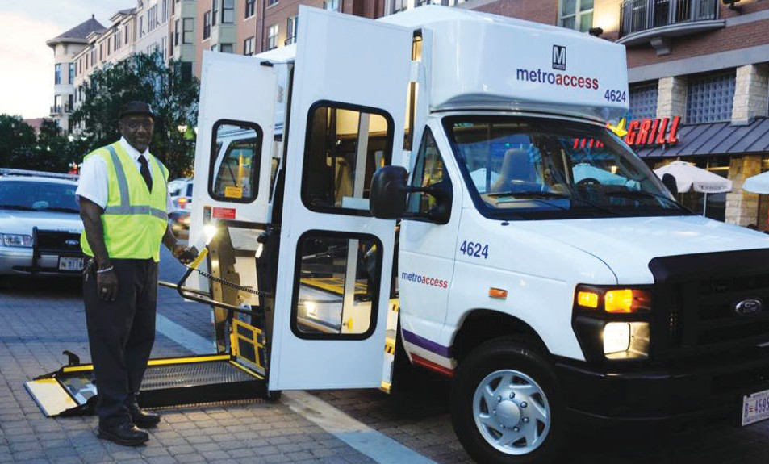
(10) and the minimum number of penalty points (3) are reached during the calendar month.
MetroAccess will retain records on customer compliance with this policy for the current calendar year.

Disputing Penalty Points and Suspensions
Customers may request to remove a no-show, late cancellation, or cancel at door penalty point from their record if the occurrence was because of circumstances beyond their control. To
dispute penalty points from no-shows and late cancellations, customers may call
the MetroAccess No-Show Team at 301- 562-5360 to explain the circumstance and request the removal of the no-show or late cancellation from their record. No-shows or late cancellations must be disputed within two business days after the end of the calendar month in which they occur.

The hours of the No-Show Team are Monday through Friday from 7:00 a.m. to 5:00 p.m. Voice messages may be left for the No-Show Team 24 hours a day, seven days a week.
Customers may also dispute suspensions
under this policy by filing an appeal. Appeal Requests must be filed in writing, by the deadline and per the instructions within the appeal packet, which will
be sent to the customer along with their MetroAccess Service Warning or Suspension Notice letter. If a customer
misses the Appeal Request deadline, their MetroAccess service will be suspended on the date listed on the MetroAccess Service Suspension Notice.

Fixed-Route Equivalent, Shared Ride Service, & Expected Ride Time
Fixed-route equivalent, under Department of Transportation (DOT) Americans with Disabilities Act (ADA) regulations at 49
C.F.R. Section 37.121(a), is defined as “each public entity operating a fixed- route system shall provide paratransit or other special service to individuals
with disabilities that is comparable to the level of service provided to individuals without disabilities who use the fixed-route system.” Paratransit service is by nature
a shared-ride service. During a trip, a customer may share the vehicle with other customers already on board, or they may be joined by customers picked up during transport. MetroAccess is not designed to reflect taxi service that typically transports passengers directly to their destination.
Customers can expect that MetroAccess
trips are comparable in ride time duration to an identical trip on Metrobus and/or Metrorail. For example, if a trip on bus and/ or rail is scheduled to take 1 hour and 5 minutes, then it should be expected that the same trip on MetroAccess would take 1 hour and 5 minutes.

MetroAccess “No Strand” Policy
MetroAccess is committed to customer safety and security. When we provide transportation to a destination other than a customer’s home, we will make every attempt to provide the return trip, even if the customer fails to appear for boarding within the scheduled pick-up window.
However, in cases where the customer fails to appear for boarding within the scheduled pick-up window for a scheduled return trip, return service will be provided as soon as possible but may be delayed because of traffic conditions and other scheduling considerations.
Exceptions to this policy include, but are not limited to, the following:
- The customer booked a one-way trip to a location and did not schedule a return trip.
- The customer requests to disembark from the vehicle before reaching his/her destination.
- The customer refuses to follow applicable operational and/or safety policies required for transport.
- The customer demonstrates inappropriate, aggressive, threatening, or abusive behavior toward others.

- At times when transportation is not possible due to weather conditions, acts of God, acts of terrorism, civil disturbances, work stoppage or any other natural disaster outside of
MetroAccess control that may cause the suspension of service.

If a customer does not appear for a scheduled trip originating from their home, MetroAccess will not send a vehicle back to the home to perform the trip, and consider the trip a no- show cancellation.

Seatbelt Securement Policy
In the interest of passenger safety, in compliance with Metro policy and applicable state laws, MetroAccess
requires all passengers to wear both the lap and shoulder belts at all times while riding the service.
State laws allow passengers with certain medical conditions to obtain a waiver from wearing the lap and/or shoulder belts, but only if healthcare providers document and certify the medical reason.
MetroAccess requires that mobility devices are properly secured. However, the use
of posey belts (those that fit around the
passenger and mobility device) is optional.
Waiver applications are available from the Office of Eligibility Certification and Outreach and are valid only upon
verification by Metro. After verifying the application, we will make a notation of the exception on the customer’s account profile.

All children seven years old and under must utilize a child safety seat during transport. The customer is responsible for providing and securing the car safety seat.
Passengers must comply with the MetroAccess Securement Policy, or have an exception on file with Metro. Drivers are not permitted to move the vehicle until all passengers are secured, and must stop the vehicle if belts are removed during travel.
For questions about the policy or to obtain a waiver application form, please email eligibility@wmata.com, or call 202-962- 2700.

Driver Assistance for Customers
MetroAccess drivers will:
- Knock on the outermost exterior door and identify themselves as “MetroAccess.” At public entrances, drivers may open the outermost
exterior door to announce their arrival; however they will not enter the building.
- In instances where public entrances have a small vestibule with a second door leading to a waiting area, drivers can open the second door to announce their arrival, but will not proceed into the waiting area.
- Not open doors at private locations or residences.
- Ask customers to show a valid MetroAccess ID card and collect full fare for trip.

- Offer the usage of a posey belt (safety belt for boarding and travel) to customers using a wheelchair or scooter.
- Offer an arm to ambulatory customers
for balance.
- Accompany (walk beside or just behind) and assist the customer along the entire path of travel between the first exterior door and the vehicle, alerting them to possible hazards.
- Guide customers who are blind or have low vision (per customer’s approval/ request).
- Maneuver the customer’s manual wheelchair (per customer’s approval/ request).
- Carry a limited amount of packages for the customer, not to exceed 40 pounds, which are capable of being transported in a single trip to the exterior door.
- Escort the customer on/off the vehicle, operate vehicle lift if required, and ensure proper securement of
the customer (including seatbelt securement) and mobility devices. Posey belts are optional.
MetroAccess drivers are not personal care attendants and are not permitted to
provide assistance beyond what is outlined in this guide. Customers are responsible for making arrangements for any additional assistance.
MetroAccess drivers are prohibited from duties typical of a personal care attendant (PCA). These include:
- Entering or unlocking a customer’s private residence at any time.
- Assisting a customer who is using a wheelchair up or down steps or curbs.
- Waiting with customers at their destination.
- Handling a service animal.
- Operating the controls of a powered mobility device.
- Making personal, unscheduled stops at the request of the customer.
- Carrying wheelchairs up or down stairs.

If You Need Additional Assistance
All customers have the right to travel with one personal care attendant (PCA) and should indicate their intent to do so when making a reservation. Depending on the nature and severity of one’s
disability, customers may require additional assistance from a PCA. Customers who cannot travel safely or comfortably without being accompanied by or met by a PCA must understand that MetroAccess drivers cannot fulfill PCA duties.
Some duties that may be performed by a PCA but not by a MetroAccess driver include and are not limited to:
- Assisting a customer in removing a jacket and/or repositioning them in a wheelchair.
- Providing physical support for a customer to walk between the vehicle and the outermost exterior door of the
16 pick-up or destination.

- Assisting a customer with changing oxygen canisters.
- Traveling with or meeting a customer who cannot be left unattended at the destination.
- Traveling with customers who cannot be left unattended for a brief time on a MetroAccess vehicle without risk to themselves or others.
- Assisting a customer who travels with a service animal but cannot board or disembark that animal from the vehicle without assistance.
- Unlocking and/or opening the door to a customer’s private residence.
- Assisting a customer using a wheelchair in navigating up or down any steps or curbs to or from the MetroAccess vehicle.
- Operating the controls of an electronically operated mobility device.
- Providing physical support (lifting from seats, transferring to seat/mobility aid).

What You May Bring with You

Life support equipment
Customers may bring a respirator, portable oxygen or other life support equipment
as long as it does not violate hazardous material transportation laws. The equipment must be small enough to fit into the vehicle and be secured. Customers must ensure that there is an adequate oxygen supply (3/4 or full) before boarding. Drivers are not authorized to operate life support equipment at any time.

Companions and Personal Care Attendants (PCAs)
Companions who are not PCAs may travel with a certified customer when space is reserved. Be sure to notify the reservation agent if a companion will ride with you
and if your companion uses a wheelchair or scooter. Companions, including children age five and older, must pay the full fare. PCAs traveling with certified customers ride for free.

Service animals

You may travel with a service animal, such as a guide dog. Snakes, birds or other exotic animals are
not considered
service animals under the ADA. Service animal means signal dog, or other animal individually trained to work or perform tasks for an individual with a disability, including, but not limited to, guiding individuals with impaired vision, alerting individuals with impaired hearing to intruders or sounds, providing minimal protection or rescue work, pulling a wheelchair, or fetching dropped items.
Be sure to tell the reservation agent when scheduling a trip that you will be traveling with a service animal. There is no fee to bring a service animal.

The service animal must be under control at all times and cannot ride on a MetroAccess seat. The service animal can ride on the floor at your feet. If the service animal displays
any aggressive or disruptive behavior, MetroAccess can require the animal be removed from the vehicle.

MetroAccess Vehicles
The MetroAccess vehicle fleet is comprised of vans that are lift-equipped and sedans. MetroAccess also partners with taxis to provide service. Vans are our primary resource for transporting
customers who use mobility aids or require a lift to board a vehicle, although vans are also used for ambulatory customers.
We reserve the right to refuse transport of an unsafe device.
Ambulatory customers utilizing the vehicle lift should use hand rails for safe boarding.

MetroAccess encourages customers to express their vehicle preference: van, sedan or taxi. MetroAccess will attempt to accommodate all vehicle preference requests.
MetroAccess vehicles feature audio and video recording while transporting customers for the safety and security of our passengers and drivers.

Direct Threat and Abusive Behavior
MetroAccess service may be suspended when customers engage in inappropriate, aggressive, threatening or abusive behavior toward other customers, MetroAccess drivers, and staff.
Inappropriate behaviors like physical assault, verbal assault, sexual assault, indecent exposure, communicating a threat, and illegal conduct may result in suspension. When this behavior
is determined to be a direct threat to the safety of others, MetroAccess
service will be immediately suspended, possibly requiring other transportation arrangements that same day.
Behaviors that delay or negatively impact service may result in a warning, followed by a suspension when the behavior is repeated. Repeat behaviors typically result in suspensions of longer duration and follow a progressive scale. Some examples include: providing misleading information during the reservation process to manipulate service; delaying service by refusing to show ID; non-payment of fare;
refusing to allow a service animal to board; refusing to move so another customer
can board; failure to comply with the securement policy; and failure to exit the vehicle when required.
This policy extends to those associated with MetroAccess customers like PCAs and traveling companions. To dispute a suspension, customers can file an appeal in writing by the deadline indicated on
the suspension notification and per the
instructions included in the appeal packet.

Severe Weather or Hazardous Conditions
MetroAccess may make service modifications during severe weather, hazardous conditions, or other emergency situations. Examples of severe weather include icy roads, snow accumulation, high winds and tornadoes. During such conditions, door-to-door service may revert to curb-to-curb service, and if warranted, service may be curtailed to return trips only or suspended altogether. Examples of hazardous conditions include

pandemics and other conditions that may jeopardize the well-being of our customers while using public transportation.
Customers are encouraged to enroll in MetroAlerts to be informed of MetroAccess service announcements.
To sign up for MetroAlerts, go to wmata.com, mouse over to “Rider Guide” and select “Subscribe to Alerts” from the dropdown menu.

MetroAccess service changes will be announced via a variety of communication mediums such as

MetroAlert messages, on local radio, television, the MetroAccess phone system, Metro’s Web site: wmata.com, and in some cases automated phone calls.

Commendations, Suggestions, and Complaints
MetroAccess wants to hear from its customers, whether it’s a commendation suggestion, or complaint.
To file a commendation or complaint regarding MetroAccess service, please use our online customer comment form at http://wmata.custhelp.com/app/home, by
- Visiting Metro’s Web site at wmata.com
- Clicking on “contact us” at the bottom of the page
- Selecting “customer comment form”
Customers can also call 202-637-0128 or TTY 202-962-2565. Agents are available weekdays from 7:00 a.m. to 8:00 p.m., and weekends from 8:00 a.m. to 8:00 p.m.
Customers may also write to us at:

Access Services - NC - 6th Floor

PO Box 44093

Washington, DC 20026-4093

Lost and Found
MetroAccess is not responsible for lost or stolen items. To report items left behind on a MetroAccess vehicle, file a report through the customer comment process options listed above.

Travel Training
Metro offers free system orientation training to teach people with disabilities how to safely use Metrobus and Metrorail. These orientations include trip-planning assistance and highlight the accessibility and safety features of the Metro system.
To arrange for a free Metro system orientation training or for more information about bus and rail accessibility, contact Metro’s Office of ADA Policy and Planning at 202-962-1100 or TTY 202-962-2033.

MetroAccess Eligibility

There are three types of eligibility:
- Unconditional Eligibility - Disability or health condition always prevents customer from using fixed-route buses or trains and they qualify for ADA Paratransit service for all trips.
- Conditional Eligibility – Customer can use fixed- route buses or trains for some trips and qualify for ADA Paratransit service for other trips when disability or environmental barriers prevent the use of fixed-route transit service.

  - Short-term Eligibility – Customer has a health condition or disability that temporarily prevents use of fixed-route buses or trains.

MetroAccess ID Cards
Customers must carry their MetroAccess ID cards with them when using the service and be prepared to present the MetroAccess ID card upon boarding.
Metro prohibits the misuse of MetroAccess ID cards.

MetroAccess ID Card Guidelines
  - Customers are required to present MetroAccess ID cards before boarding all MetroAccess vehicles.
  - The MetroAccess ID card is issued to designated approved users only.
  - The MetroAccess ID card is not transferable so customers must not give or lend MetroAccess ID cards to anyone.
  - The MetroAccess ID card allows customers to travel with one personal care attendant (PCA) free of charge.
  - Misuse, alteration or counterfeiting of MetroAccess ID cards is a violation of the laws of the District of Columbia, Maryland and Virginia.

Replacing a Lost or Stolen MetroAccess ID Card
  - To report a lost or stolen MetroAccess ID card, immediately call 202-962-2700. The first replacement card carries a
$10 replacement fee. All subsequent replacements are $25 each. Fees are waived if the ID card was stolen and the customer provides a police report
documenting said theft. Broken or worn cards are replaced without cost.
- Replacement ID cards can berequested in-person at the MetroTransit Accessibility Center or in writing.
- When writing for a replacement card, please send requests to:

Metro Transit Accessibility Center 655 Virginia Avenue SW Washington, DC 20024
- Include name, date of birth, address, contact phone number and MetroAccess ID number on each
request. Enclose the appropriate fee in the form of cashier’s check or money order. Do not send cash through the mail. Replacement ID cards will be forwarded to the address provided.

MetroAccess SmarTrip® ID Cards for Customers with Conditional Eligibility
Customers with conditional eligibility will be issued a MetroAccess SmarTrip® ID card, which enables free rides on Metrobus and Metrorail. The customer may be accompanied by a PCA who can also ride free. One PCA SmarTrip® card is issued per conditionally eligible customer.

MetroAccess SmarTrip® ID Card Guidelines
The MetroAccess SmarTrip® ID card:
- Is non-transferable and cannot be used by anyone other than the certified customer.
- Is pre-registered to the customer by Metro.

  - Requires recertification to avoid deactivation. For information on MetroAccess recertification, call 202-962-2700.

Using the MetroAccess SmarTrip® ID with Accessible Metrobus and Metrorail
Metrobus and Metrorail offer accessible transportation options for all passengers, including those with disabilities. These accessible fixed-route services do not require a reservation. To take advantage of the free rides benefit with Metrobus and Metrorail, the customer should tap the MetroAccess SmarTrip® ID card on the SmarTrip® target when boarding.
PCAs must tap their PCA SmarTrip® card on the same SmarTrip® target following the MetroAccess customer (within
90 seconds).

Personal Care Attendant (PCA) SmarTrip® cards
One PCA SmarTrip® ID card is issued per eligible customer. The PCA SmarTrip® card is linked to the MetroAccess SmarTrip®
ID card. To ride without fare, the personal care attendant must tap the PCA card immediately after the MetroAccess SmarTrip® ID card is tapped on the same SmarTrip® target.
IMPORTANT: Full fare will be deducted if the PCA SmarTrip® card is:
  - Tapped on another SmarTrip® target.
  - Tapped on the same SmarTrip® target, but more than 90 seconds after customer’s MetroAccess SmarTrip® ID card is tapped.
- Used independently from the customer’s MetroAccess SmarTrip® ID card.

Benefits of MetroAccess SmarTrip® ID Card Online Account
MetroAccess SmarTrip® ID card online accounts are accessible at https://www. wmata.com/fares/smartrip/ and offer the following benefits:
- Easy account set-up, auto reload of funds, and a simple way to add value.
- Ability to manage multiple SmarTrip® cards and view card balances.
- Simple process to report lost, stolen or damaged cards.

Adding fare to a MetroAccess SmarTrip® ID card or Personal Care Attendant SmarTrip® card on Metrobus
To add fare to MetroAccess SmarTrip® ID card or PCA SmarTrip® card when using Metrobus, customers should:
- Push the “add fare” button on the fare box.
- Tap their MetroAccess SmarTrip® ID card or PCA SmarTrip® card to the SmarTrip® target.
- Insert money.

Adding fare to a MetroAccess SmarTrip® ID card or Personal Care Attendant SmarTrip® card on Metrorail
To add fare to MetroAccess SmarTrip® ID card or PCA SmarTrip® card when using Metrorail, customers should:
  - Tap the MetroAccess SmarTrip® ID card or PCA SmarTrip® card to the SmarTrip® target.
  - Press B to add fare.
  - Insert cash or credit/debit card.
  - Tap card again.
Customers can also add value at an authorized retail outlet. Visit wmata.com/ fares/purchase/where.cfm for location information.

Using the MetroAccess SmarTrip® ID with Regional Transit Providers
Conditionally eligible MetroAccess customers may use their SmarTrip® ID card to board other regional transit
systems. The lists below describe which systems the customer may ride for free, for a discounted fare, or for full priced fare in the Washington metropolitan area.

Ride free on:
  - Metrobus
  - Metrorail
  - DASH
  - DC Circulator
  - Arlington Regional Transit (ART)
  - Fairfax CUE
  - Fairfax Connector (most routes)
  - Prince George’s The Bus
  - Montgomery County Ride On

Get discounted fares on:
- Potomac and Rappahannock Transit (PRTC)
- MARC train and MTA services
- Amtrak® reservation (10% discount)

Full priced fares on:
- Other local bus systems (free bus-to- bus transfers within a two-hour window included)
- Parking at all Metro parking lots and garages
Customers are not required to schedule rides in advance when using these transit systems. For more information about regional transit providers who offer specialized transportation options for people with disabilities, visit ReachARide. org, or contact them on their toll-free hotline at 855-732-2427. Using these services does not affect MetroAccess eligibility.

Replacing a lost or stolen MetroAccess SmarTrip® ID card
The fastest way to get a replacement card is to visit the Transit Accessibility Center at 655 Virginia Avenue SW, Washington, DC 20024.

Office Hours:
Monday, Wednesday, Thursday, Friday: 8:30 a.m. to 4:00 p.m.
Tuesday: 8:30 a.m. to 2:30 p.m.

Please note:
- There is a $10 replacement fee for a replacement MetroAccess SmarTrip® ID card, $25 for each additional lost card. The fee is waived for a stolen card reported to police.

  - The replacement fee for a Personal Care Attendant (PCA) SmarTrip® card is
$2.00.
  - Replacement fee is waived for a defective or damaged card.
  - Keep a copy of the serial number from the back of the card for reference.
  - Cards are not sold in Commuter Stores.

Abilities-Ride Program
Abilities-Ride offers safe and accessible alternative transportation services to MetroAccess customers. Trips provided through the Abilities-Ride program are not MetroAccess trips. Abilities-Ride trips are provided by privately-owned and operated taxi, van, and similar service providers at a significant discount.
Key differences from MetroAccess trips:
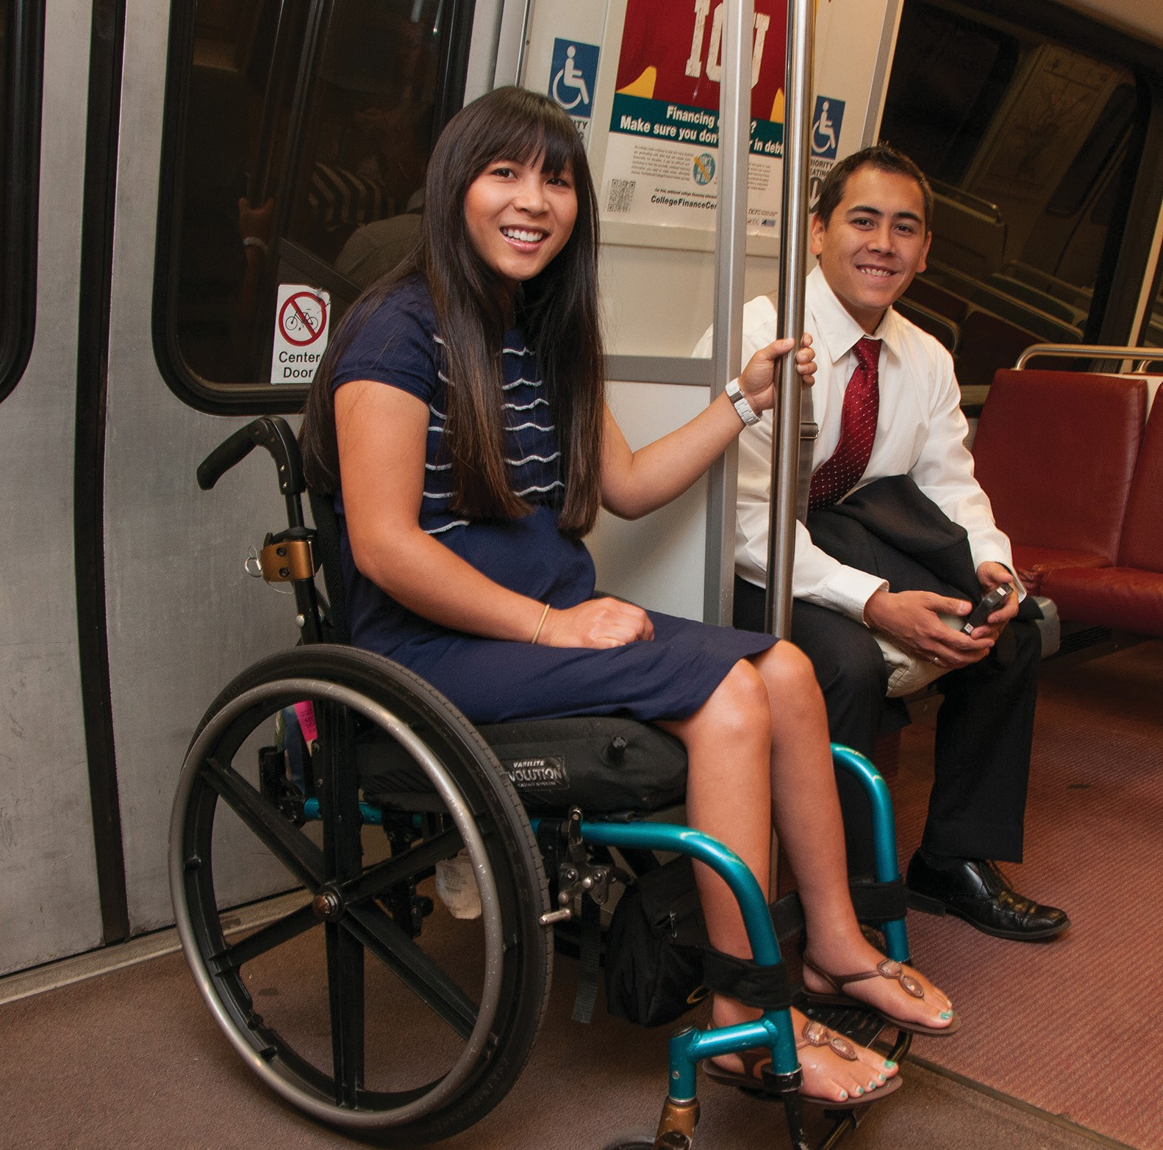
  - Abilities-Ride providers offer curb-to-curb service, not door- to-door.
  - Abilities-Ride drivers are not required to carry customer bags or luggage.
  - Abilities-Ride drivers are not required to wait with a
customer for a “hand-off” at trip
destination location.
Currently, there are 11 companies offering service through the Abilities-Ride program: Action Taxi, BBC Connect, Curb, Falcon, Old Dominion Taxi, Regency Taxi, Silver Cab, Transco, Uber, Via, and Yellow Cab.
Customers interested in discounted, direct, non-shared ride trips through Abilities-Ride may contact Metro at access@wmata.com.

Benefits:
- Take up to four rides per day.
- Discounted fare.
- One personal care attendant (PCA) can travel free of charge.

Conditions:
- Must be currently eligible for MetroAccess.
For more information on the Abilities-Ride program or for help getting started, please email Metro’s Department of Access Services at access@wmata.com or by phone at 202-962-2100.

Frequently Asked Questions about MetroAccess

Paratransit Service

What is paratransit service?
Paratransit is public transportation for people who cannot ride the bus, train, or other publicly available modes of transportation because of their disability. Paratransit providers are required, at a minimum, to offer fixed-route equivalent service to within ¾ of a mile.

What does fixed-route equivalent mean?
Fixed-Route Equivalent Service is public transportation being made available during the same time and in the same area(s) that bus and rail services are available.

How long does a paratransit trip take?
A paratransit trip can take as long as a fixed route equivalent trip can take. Meaning if your trip from Point A to Point B would take 2 hours for someone using bus and/or rail service, then the paratransit trip can take up to two hours as well.

What is a shared-ride service?
A shared-ride service means that when you are picked up there may already be a passenger on board the vehicle, and/or the vehicle may stop to drop-off or pick-up another passenger before you get to your destination.

Frequently Asked Questions about MetroAccess

Eligibility

How do I become eligible for MetroAccess paratransit service?
To be eligible for MetroAccess service, applicants must have a disability as defined by the Americans with Disabilities Act (ADA) and be unable, as a result of a disability, to utilize accessible fixed-route transportation such as Metrobus and Metrorail, or be unable to travel to/from a bust stop or rail station due to a disability. This is determined by submission of a completed application and completion of a functional assessment.

How do I get an application to apply for MetroAccess?
An application can be requested by:
- Visiting www.wmata.com/service/accessibility and following the links to download an application
- Emailing eligibility@wmata.com
- Mailing or visiting:
Transit Accessibility Center 655 Virginia Ave SW Washington, DC 20024
- Calling 202-962-2700

How long does the application process take?
Written notification of the eligibility determination will be sent via mail within 21 days of the
assessment appointment.

Are there different types of eligibility?
Yes, customers can be granted full, conditional, or short-term eligibility for MetroAccess based on the completed application and functional assessment.

I have a permanent disability, why do I have to re-certify?
MetroAccess eligibility is based on a combination of a customer’s disability and functional ability to use fixed-route services (bus & rail). Therefore, all customers are required to recertify for service periodically, regardless of disability type or duration, as allowed by the Americans with Disabilities Act (ADA). Please contact the Transit Accessibility Center for instructions on how to recertify for MetroAccess.

Frequently Asked Questions about MetroAccess

How do I replace a lost or stolen MetroAccess or Reduced Fare photo Identification Card?
MetroAccess customers can obtain a replacement SmarTrip® photo ID when the original has been damaged, lost, or stolen. There is a fee for replacement of a lost ID card. The fee is $10 for the first replacement card and $25 for the second or subsequent replacement card. This fee is waived if the ID card was stolen and the customer can provide a police report which documents the theft. Additionally, the fee is waived if the ID card is worn or otherwise unserviceable, such as broken or cracked. Replacement card requests may be made in person or by mail to the Transit Accessibility Center.

What if I am denied eligibility for MetroAccess?
Applicants have the right to appeal if found ineligible for MetroAccess. Information on the appeal process will be sent along with notification of ineligibility. All MetroAccess appeals should be sent to Metro’s Office of ADA Policy and Planning.

Frequently Asked Questions about MetroAccess

MetroAccess Service

Why do I always have to share a ride with other people?
MetroAccess is a fixed-route equivalent public transportation service, meaning that it is no different than the Metrorail or Metrobus service, both of which are shared-rides among
many passengers. When using a public transportation service all customers should expect to share their rides with other members of the public.

What if I need more assistance than the driver can provide?
If customers need more assistance than can be provided by a driver, they will likely need to travel with a PCA, a Personal Care Attendant (PCA) and should indicate their intent to do so when making a reservation.

My driver always arrives early. Can the driver leave me if I’m not ready?
When the driver arrives before the pickup window begins, they cannot leave until they have waited for five minutes after the start of the pick-up window. For example, if the pick-up window is from 8:00 a.m. to 8:30 a.m. and the driver arrives earlier than 8:00 a.m., the driver will not depart before 8:05 a.m., five minutes into the pick-up window. Customers are not required to board the vehicle until the pick-up window begins, but may board the vehicle early if they chose to do so.

How can I recognize my driver?
Drivers must be in uniform with their ID card visible. If you ever have doubt about the driver’s identity, call MetroAccess at 301-562-5360 and select option 2 to speak with a dispatcher (TTY 301-588- 7535).

Can I call MetroAccess for a ride to the hospital if I need immediate medical attention?
MetroAccess does not provide sameday service nor is it a substitute for an ambulance. If you have an emergency, please call 911.

I don’t like vans. Can I get a sedan for every trip?
MetroAccess cannot guarantee a customer a specific type of vehicle. However, MetroAccess encourages all customers to express their preferences, and we will do our very best to accommodate all requests.

Frequently Asked Questions about MetroAccess

What is InstantAccess?
InstantAccess is the MetroAccess automated telephone service that supports MetroAccess trip confirmation, cancellation, and account information using the keypad of any touch-tone telephone. The system is available 24-hours a day at 301-562-5360 (TTY 301-588-7535).

How do I know when the MetroAccess driver has arrived?
Whenever possible, an automated call announcing the vehicle’s arrival may be placed to a phone number of your choosing; however, a call cannot be guaranteed for all trips.
Customers can expect the driver to knock on the outermost exterior door for pick-up when the customer is not readily available upon arrival. At public entrances, drivers may open the first exterior door to announce their arrival; however, they are not permitted to enter the building. If the entrance has a second door leading to a waiting area, drivers may open the
second door and announce their arrival, but will not proceed into the waiting area. Drivers are not permitted to open doors at private locations or residences. Drivers will identify themselves as “MetroAccess,” be in uniform and present a visible ID card.

What does Door-to-Door service mean?
Door-to-door service means that for each trip a MetroAccess driver will either meet you at the outermost exterior door and escort you to the vehicle or escort you from the vehicle to the outermost door of your destination.
Door-to-Door service does not include assisting passengers on unsafe or steeply inclined mobility ramps or stairs; entering beyond the outermost exterior door; locking or unlocking doors; activating or deactivating house alarms; or loading or unloading personal items.

What is the MetroAccess fare?
MetroAccess fares are capped at a maximum flat fare of $4.50 per trip. Should twice the fixed route equivalent fare for a similar trip be less than the one-way paratransit $4.50 flat fare, customers will be charged the lower fare. The fares went into effect on Monday, July 1, 2024.

Why are my trip credits being posted differently?
MetroAccess trip credits will now be posted for each late trip, instead of in one monthly sum; these credits are posted around seven business days after the trip occurs.

What payment methods will be accepted for MetroAccess fares?
MetroAccess fares can be paid in cash or prepaid by phone or online using a credit or debit card with MetroAccess EZ-Pay. For cash payments, the driver will ask for payment upon first contact with the customer, usually at the door. For more information on utilizing EZ-Pay, see EZ-Pay in the Customer Guide.

Frequently Asked Questions about MetroAccess

How do I know if I am grandfathered and allowed to travel outside the ADA

service area?
In accordance with ADA guidelines, on July 1, 2010 the MetroAccess service area changed to provide paratransit service to locations within 3/4 mile of fixed-route transit services such as Metrobus and Metrorail during the same hours as fixed route services. To continue providing the same level of service to customers who had traveled outside the ADA service area and hours between July 1, 2009 and June 30, 2010, Metro’s Board of Directors adopted a grandfathering provision to allow those customers to continue to use the service beyond the newly designated service area and hours of operation. To know if the grandfathering provision applies to you, please check with a MetroAccess reservations
agent at 301- 562-5360 or check online to verify your status. To check online, simply log into the MetroAccess online account, and if eligible, the term “grandfathered status” will appear under the account’s Eligibility Status.

What happens if I move to a new address?
Grandfathered customers can move to a new home address and remain grandfathered, but those not grandfathered cannot become grandfathered under any circumstance.

How do I know if my destination is in the ADA service area?
Customer pick-up and drop-off locations must be within ¾ mile of fixed-route transit services such as Metrobus and Metrorail, also known as “in the Transit Zone” (see ‘What is MetroAccess?’ on page 4) during the same hours that fixed-route services are available. Please check with MetroAccess at 301-562-5360 to verify service availability in your area.

Can drivers make a stop between trips?
No, drivers cannot make stops between trips. For driver and customer safety, personal stops are not allowed. Requests to leave the vehicle before reaching the scheduled destination will result in travel termination at the newly requested location.

Can drivers help me carry my personal luggage and bags?
Drivers may carry a limited amount of packages for the customer, not to exceed 40 pounds, that are capable of being transported in a single trip to the exterior door.

If my mobility device breaks down, can the driver fix it for me?
No, drivers cannot fix mobility devices. Customers are responsible for ensuring that personal assistance/ mechanical devices (e.g., wheelchair, scooter, oxygen device) operate without driver intervention.

Frequently Asked Questions about MetroAccess

What are my responsibilities when riding MetroAccess?
You must not engage in any disruptive, illegal or violent behavior while riding MetroAccess. You must be prepared to travel at the start of your pick-up window. Other responsibilities include:
- Display a valid MetroAccess ID Card to the driver before boarding
- Pay exact fare to the driver upon request
- Utilize required vehicle restraints during transport
- Keep service animals under control
- Avoid eating, drinking, or smoking in MetroAccess vehicles
- Treat drivers, other riders, and MetroAccess staff with respect
- Maintain good personal hygiene
- Cancel reservations two or more hours before the scheduled pick-up

What is a “no-show”?
A “no-show” occurs when a customer does not present themselves for boarding within five
minutes of the vehicle’s arrival (within the 30-minute pick-up window). What are ways to best be safe when riding MetroAccess? Partner with the MetroAccess driver – follow their safety instructions.
- Accept driver escort offers (take the driver’s arm for balance) or prepare to walk near the
driver, so that he/she can provide alerts to hazards along the path of travel.
- Know your limits - bring a Personal Care Attendant (PCA) along if:
  - You need support when walking to/ from the vehicle (or bring a mobility aid).
  - You cannot be left alone at the drop off location.
- Ensure that personal assistance/ mechanical devices (ex. wheelchair, scooter, oxygen device) operate without driver intervention.
- Keep mobility aids in good working order.
- Be able to operate power chairs safely.
- Ensure that brakes operate as designed.
- Make sure privately-owned ramps, sidewalks, and walkways are maintained and are clear of obstructions, snow, and ice.
- Ambulatory customers utilizing the vehicle lift should use handrails for safe boarding.

Frequently Asked Questions about MetroAccess

Alternatives to MetroAccess Service

What less expensive alternatives are there to MetroAccess?
MetroAccess customers who are conditionally eligible, who show a valid white MetroAccess ID, along with one companion, may ride for free on Metrorail, Metrobus, and the following regional transit providers:
- Arlington County ART
- Arlington STAR
- City of Fairfax CUE Bus
- DC Circulator
- Fairfax Connector
- Montgomery County Ride On
- Prince George’s County TheBus
You do not need to schedule rides in advance when using these transit systems, giving you the flexibility to travel independently and spontaneously. Using these services does not affect your eligibility to use MetroAccess.
People with disabilities who are not certified MetroAccess customers and travel on Metro’s fully accessible bus and rail system can take advantage of Metro’s Reduced Fare program. People with disabilities who qualify for the program pay half the regular fare on Metrobus and Metrorail. For more information on this program, contact 202-962-2700 and select option 1.
MetroAccess has also introduced the Abilities-Ride program, which offers MetroAccess customers discounted trips when one or more of their trips are selected to be moved to another service.
For MetroAccess customers who are residents of Washington, DC, there is the TransportDC program which offers same-day service on taxicabs for a flat $5 for trips that begin and end in Washington.

I have never used Metrorail or Metrobus. Who can I call for help?
Metro has a free travel training program to teach people with disabilities how to travel independently on Metrobus and Metrorail. Training can be provided on using specific routes, stops, and stations. Training sessions are customized based on individual’s needs. For more information, please call Metro’s Transit Accessibility Center at 202-962-2703 or TTY 202- 962-2033 or email traveltraining@wmata.com.

Frequently Asked Questions about MetroAccess

How can I find out more about the Abilities-Ride program?
To find out more about the Abilities-Ride program, please go to wmata.com. At the top right of the screen you will find a search command. Please search Abilities-Ride. Click the first link and that will take you to the Abilities-Ride page where you can read about the program and enroll yourself into the program. If you don’t have access to the internet, you can 202- 281-8984.

How can I find out more about the TransportDC program?
To find out more about the TransportDC program, please go to dfhv.dc.gov. At the top right of the screen you will find a search command. Please search TransportDC. Click the first link and that will take you to the TransportDC page where you can read about the program.

MetroAccess Pick-up/Drop-off Locations at Metrorail stations

Station Name Bus Bay Station Name Bus Bay

Addison Road E
Anacostia G
Ballston E
Benning Road Benning & 45th St NE
Bethesda C
Braddock Road C
Branch Ave. H
Brookland/CUA A
Capitol Heights C
College Park E
Congress Heights D
Crystal City D
Deanwood A
Dunn Loring E
East Falls Church D
Eastern Market Penn Ave & 8th St SE
Eisenhower F
Federal Center SW 3RD St SW & D St SW
Forest Glen D
Fort Totten C
Franconia-Springfield D
Glenmont D
Greenbelt G
Grosvenor-Strathmore F Huntington C
King Street-Old Town D
Landover D
Largo Town Center D
Medical Canter F
Minnesota Ave. B
Morgan Blvd. E
Navy Yard M St &
New Jersey
Ave SE
Naylor Road D
New Carrollton A
Pentagon City Hayes St & 12th St
Potomac Ave. Potomac Ave & 14th St SE
Prince Georges A
Rhode Island Ave. B
Rockville (East Side) B
Shady Grove C
Silver Spring 101
Southern Ave. C
Stadium Armory 19th & C SE
Suitland C
Takoma F
Twinbrook (West Side) A Tysons Corner (North Side) C Van Dorn A
Vienna M
Waterfront M St & 4th St SW
West Falls Church D
West Hyattsville D
Wheaton E
White Flint Marinelli & Rockville Pike

Useful Numbers
Event Calendar
The Accessibility Advisory Committee meets 5:30 p.m. - 7:30 p.m. on the first Monday of every month.
The Accessibility Advisory Bus/ Rail Subcommittee meets 4 p.m.
- 6 p.m. on the second Monday of every month.
The Accessibility Advisory MetroAccess Subcommittee meets 4 p.m. - 6 p.m. on the third Monday of every month.
These meetings take place on Mondays except on holidays; in which case, the meeting moves to Tuesday.
MetroAccess 301-562-5360
TTY 301-588-7535
Toll Free 800-523-7009
Office of Eligibility Certification
and Outreach
Transit Accessibility Center 202-962-2700
TTY 202-962-2033
Metro Outreach and Travel Training 202-962-2703
TTY 202-962-2033
Reduced Fare ID Office
202-962-2700
TTY 202-962-2033
Office of ADA Policy and Planning
202-962-1100
TTY 202-962-2033
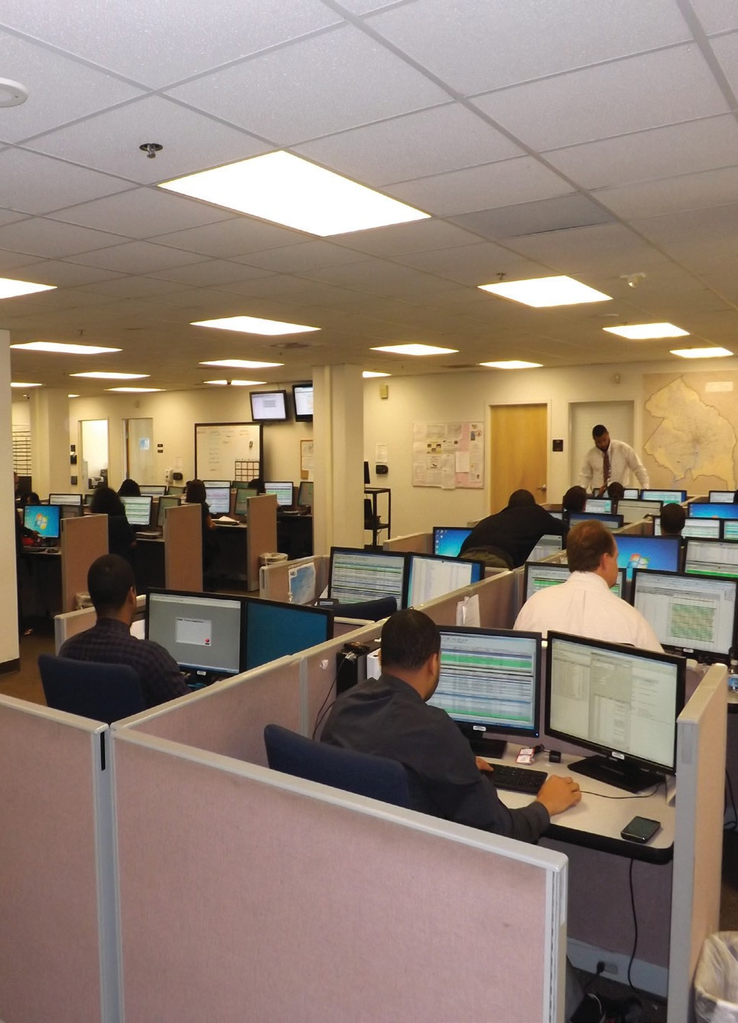
MetroAccess Customer Service 202-637-0128
TTY 202-962-2565
Customer Information 202-637-7000
TTY 202-638-3780
wmata.com
Elevator Outages and Metrorail Service Disruptions
202-962-1212
Elevator Outage/Shuttle Requests 202-962-1825
TTY 202-638-3780
Transit Police 202-962-2121

Department of Access Services 655 Virginia Avenue SW Washington, D.C. 20024
35

